Title (Arial font: size 14 point)

Author’s Full Name¹ (e.g., Yu-Ting, Hsieh¹), Author’s Full Name*²
¹ Affiliation of the First Author
² Affiliation of the Second Author

Presenter. Author’s position, Email
*Corresponding author. Author’s position, Email

Abstract | For the text use Arial font 12 point, justified paragraphs, simple line spacing (1.0). You can copy and paste your text here but keep the page margins the same as is set here as well as the left indent. The acceptable word range for the abstract is 200 – 375 words. The limit for your abstract is one page. The abstracts which do not meet those guidelines will be asked for revisions. Figures can also be used in the text.

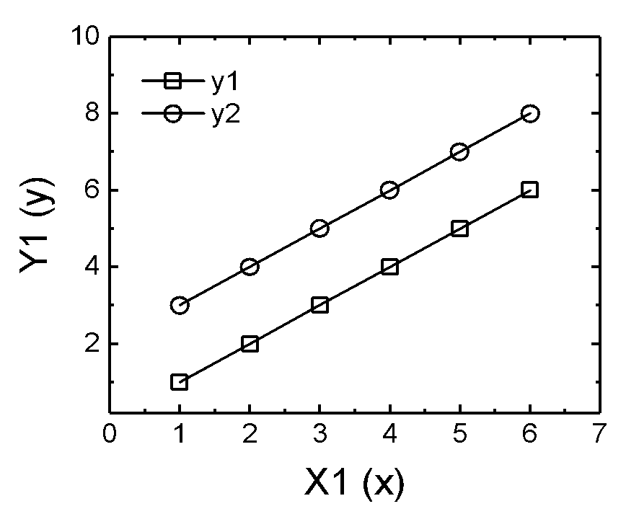
Figure 1. For the figure caption use Arial font, 10 point and italic

Use the template, follow the format and submit your abstract to nanofiltration2026@gmail.com.

Keywords | Nanofiltration; Conference; Membrane. (six words maximum)

* Please underline the name of the presenter.
* Deadline for abstract submission is November 30, 2025.
* Authors will receive an email confirming the receipt of your submission by the NF2026 Secretariat.

